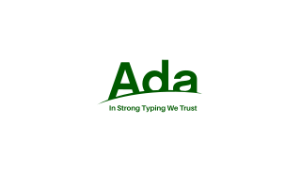

Explore

**Ada** is a **structured, statically typed, imperative, and object-oriented high-level programming language** inspired by Pascal and other languages. [It offers built-in support for design by contract, strong typing, explicit concurrency, tasks, synchronous message passing, protected objects, and non-determinism1](https://en.wikipedia.org/wiki/Ada_%28programming_language%29).

Here are **five free resources** where you can learn Ada:

1. [**Introduction to Ada**](https://learn.adacore.com/courses/intro-to-ada/index.html): This course covers the basics of Ada programming and is suitable for those with a basic understanding of programming techniques[2](https://learn.adacore.com/courses/intro-to-ada/index.html).
2. [**About Ada**](https://www.adacore.com/about-ada): AdaCore provides an overview of Ada, emphasizing its reliability, efficiency, and support for various target processors and development environments[3](https://www.adacore.com/about-ada).
3. [**Ada-95: A guide for C and C++ programmers**](https://www.linuxlinks.com/excellent-free-tutorials-learn-ada/): A tutorial by Simon Johnston aimed at C and C++ programmers[4](https://www.linuxlinks.com/excellent-free-tutorials-learn-ada/).
4. [**Ada 95 tutorial**](https://www.linuxlinks.com/excellent-free-tutorials-learn-ada/): Gordon Dodrill’s tutorial for learning Ada 95[4](https://www.linuxlinks.com/excellent-free-tutorials-learn-ada/).
5. [**Ada–A Crash Course**](https://www.inf.ed.ac.uk/teaching/courses/fv/spark/Ada-A_Crash_Course.pdf): Peter C. [Chapin’s concise overview of Ada, perfect for getting started quickly](https://en.wikipedia.org/wiki/Ada_%28programming_language%29)[5](https://www.inf.ed.ac.uk/teaching/courses/fv/spark/Ada-A_Crash_Course.pdf).

Happy learning! 🚀🔍📚